Shifting Paradigms in Dementia 5: Architecture, Design and Dementia
Iris Murdoch Building, University of Stirling May 31st

Schedule for the day

10.00 – 10.30 Arrivals, tea and coffee

10.30 – 12.45 Co-Design Workshop with Edinburgh School of Architecture and Landscape Architecture (ESALA)
Creating dementia-enabling environments

12.45 – 1.30 LUNCH

1.30 – 2.00 Design workshop feedback ESALA students

2.00 – 2.30 Chrissy Buse
Design for dementia in practice: following ‘buildings in the making’

2.30 – 3.30 Jos Boys
Starting from Difference

3.30 - End Final questions / Thank-yous and Goodbyes

Workshop and presentation outlines:
Co-Design Workshop with Edinburgh School of Architecture and Landscape Architecture
Working in Interdisciplinary design teams, with students of Architecture from the University of Edinburgh (ESALA), workshop participants will produce ideas, drawings and models of ideal home environments for people with dementia. Staff from the Dementia Services Development Centre and ESALA will also be there to facilitate and take part in discussions and the production of ideas and proposals.
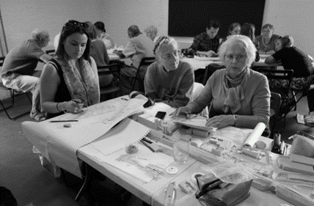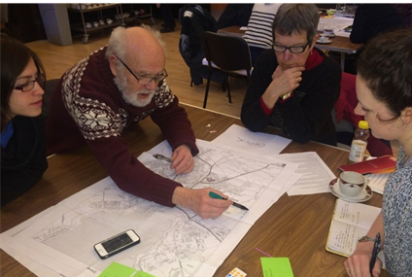

Design for dementia in practice: following ‘buildings in the making’
Christina Buse (Presenter), Sarah Nettleton, Daryl Martin (University of York), Mikaela Patrick and Chris McGinley (Helen Hamlyn Centre for Design)
This presentation explores how ideas about good practice in designing for dementia and later life are translated, and the opportunities and challenges for people-centred design that occur during a building project. It draws on data from an ESRC funded study Buildings in the Making that followed different building projects for older people, focusing on care homes and extra care housing, using qualitative, ethnographic methods including observation, interviews and documentary analysis. The presentation examines how older people with dementia are imagined by architects and other members of the design and construction team, and the extent to which consultation with people with dementia takes place. It also discusses how good practice in designing for dementia can come into tension with different regulatory requirements, financial constraints, the competing requirements of different stakeholders, as well as tensions between promoting independence and concerns for safety. The presentation also considers who advocates for the older person with dementia in the design process, and how this knowledge may be lost or undermined by wider factors relating to models of commissioning and procurement.

Starting from Difference
In this talk Jos Boys will explore how starting from difference - by both valuing, and learning from, human bio- and neurodivergence – can lead to innovative and creative building design. She will outline the work of the DisOrdinary Architecture Project, a group that develops and captures new models of practice for the built environment, led by the creativity and experiences of disabled artists. And she will explore some examples of work that suggest directions for doing disability and architecture differently.

Speaker bios:
Iain Scott - Event Leader
Iain Scott is an ARB registered Architect and educator with 24 years of experience of practice in the UK and Asia. He has been a design tutor at Edinburgh College of Art and ESALA since 1996 and was Director of the Master of Architecture at ESALA from 2011-14.
Iain is also a researcher within ESALA, working on projects funded by joint research council initiatives. Previous projects include ‘Mobility, Mood and Place’, an interdisciplinary research project which received £1.5 million funding from Research Councils UK and involved academics and students from a series of different fields across a number of different institutions. The project investigated the relationship between older people and the built environment, with fieldwork and user participation in the cities of Manchester, London and Copenhagen and also the remote Scottish Island of Orkney. His previous research includes work with disenfranchised users of the built environment, ‘Design for Autism’ (2009) and ‘Effective Briefing Techniques for Building Users with Communication Difficulties’ (2011) being two notable previous publications. Latest work includes working with colleagues on Knowledge Exchange project with the Wheatley Group, assisting them with the development of a contemporary property development and technology strategy. Iain is interested in a compelling and fundamental relationship between his teaching and research to the extent that the boundaries between the two disciplines become indistinct. His design studios at ESALA are interdisciplinary, engaging post-graduate students of Architecture and Landscape Architecture in diagnosing problematics and identifying opportunities for design solutions which add to the knowledge canon in particular subject domains and geographical places. ESALA Masters, research-led studio for 2017-18 is based in Tuscany, Italy and is called, ‘MMP Tuscany- Re-Imagining Communities and Ancient Traditions for a Rural Ageing Population’.

Dr. Chrissy Buse is a lecturer in Sociology and Social Psychology, and the researcher on the ESRC funded ‘Buildings in the Making’ project (running from August 2015 until July 2018), working with Sarah Nettleton (PI) and co-investigators Daryl Martin, Ellen Annandale, Sian Beynon Jones (York), Lindsay Prior (Queens Belfast) and Julia Twigg (Kent).
After completing a degree in Sociology and Psychology in Liverpool, Chrissy then completed an MSc in Sociological Research in Manchester. Her dissertation research explored the use pro-anorexia websites. She then went on to complete a PhD at the University of York, examining the use of information and communication technologies in retirement, and the location of technology use within ‘embodied techno-biographies’. Chrissy has since worked as a researcher at the Universities of Leeds and Kent on various projects concerning the embodied health and social care needs of older people. Her recent research includes the Dementia and Dress project with Julia Twigg, a study examining the significance of clothing and dress in the lives and experiences of people with dementia, their carers and care workers.

Dr. Jos Boys is co-director of the DisOrdinary Architecture Project, a platform led by disabled artists to explore how disability, in all its multiple manifestations, can be a creative generator for architectural practice, rather than seen as a regulatory ‘problem’. She has a background in architecture, and is also an educator, researcher and writer. She has published two books on new ways of thinking about architecture and disability, and DisOrdinary currently has Arts Council funding for disabled artists to work in architectural education across the UK, to experiment with different ways of ‘doing disability’ in design. She will talk about what the creative implications are for building design of starting from our many and diverse forms of human embodiment.

